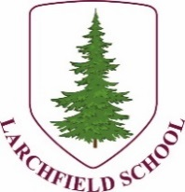


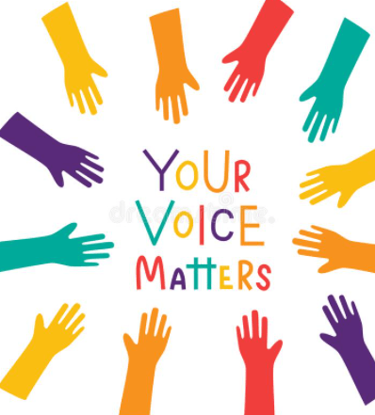
Pride in
the Badge
We asked
What do you like about our school?
You said…
All people are nice
Library
Learning
Friends
Buddy Bench
MUGA
Trim trail
Learning something new every day
Nice classroom space
Basketball court
Quiet space outside Y1 (Reading Nook)
Daily mile track

We asked you
What do we think could be better?
You said …
Tidy library with books put back.
Give the grass a rest to grow back.
Rubbish on the floor (wrappers), you said people take things from their lunch boxes mainly.
Having swings.
Mini quizzes.
Strawberry jelly.

We asked
Where do you feel safe when you are at school?
You said…
Classroom
Library
Near teachers
Lunch hall
We asked?
Do you feel less safe anywhere when you are in school?
You said…
MUGA, get hurt playing football
On the hard surface on the playground when you fall

Next meeting
Friday 2nd February – 1.15

