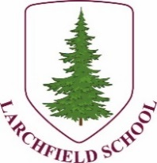
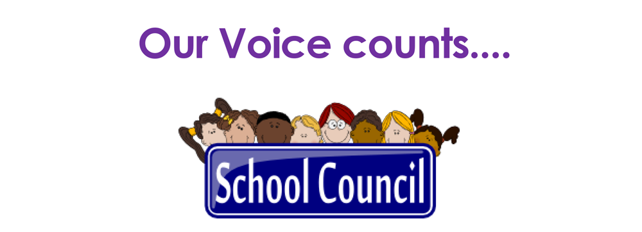

Tuesday 6th February
We asked you
What do we think could be better in school?
You said …
Display SMART rules around school
Put SMART rules on laptop wall paper
Make up slogans about keeping safe on line (Passwords ae like toothbrushes, don’t share!)
Have books about online safety
We asked
What can we do at home and in school to keep safe online?
Everyone said…
Tell a trusted grown up if something upsets you
Don’t press random pop ups
Report or block people you don’t know
Y1 - Always have a grown up with you
Y2 - Don’t press accept friend requests from people you don’t know
Don’t tell anyone your name
Just use Kids Youtube
Parents put on controls
Don’t speak to strangers
Y5 – Use SMART rules
Anti-virus apps
Parental controls
Official laptops
Don’t go on apps you don’t know
Y6 – Think twice
Don’t share details
Hide school badge
Ask permission if taking a picture of someone
Only use trustworthy sites

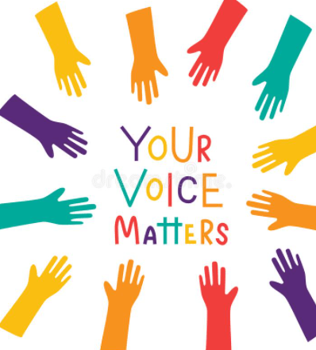

Pride in
the Badge

Next time
Being Respectful –
How do we already look after our school?
How can we be more respectful towards school equipment?

Next meeting
Friday 1st March – 1.15

