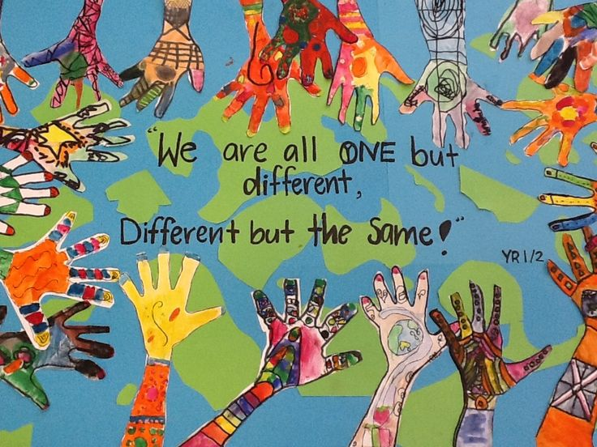
English
- The Boy at the Back of the Class
- Information Texts
- Persuasive Letter
- Narrative
- Biography
R.E
- Why is it better to be there in person?
- Why is there suffering?

Spanish
- Household Task in Spanish
- Shopping in Spain

PE
- Basketball
- Gymnastics
- Hockey
- Sports Leaders

Science
- Classification: Animals including humans
- Evolution: Living things and their habitats

Geography
- Economic Activity

PSHE
- Safety
- Changing Bodies

Art / DT
- Wind Sculptures- Yinka Shonibare
- African Masks- clay

Computing
- Programming into Python
- Online Safety
- Data handling

History: British and Black
KQ1: How shall we tell the story of the first Black people in Britain?
KQ2: What does the evidence tell us about the role of Black people in Tudor society?
KQ3: What difference did the slave trade make to the experiences of Black people in Britain?
KQ4: When Black people rushed to enlist why has Black peoples’ role in World War One and Two rarely been celebrated?
KQ5: From Windrush to Notting Hill – What was the experience of the first post-war Black immigrants?
How did the arrival of the Empire Windrush change the way Black people were treated in Britain?
KQ6: How far has life improved for Black people living in Britain in the last 60 years?

Music
- Film Music
- Theme and variation (Pop Art)

Our Diverse World
Maths
- Ratio
- Algebra
- Decimals
- Fractions
- Percentages
- Statistics

Year 6 –Spring Term

