
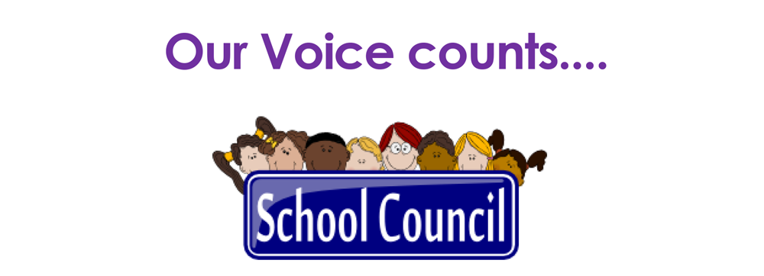

We asked
What rewards and consequences should there be in school for different behaviour choices?
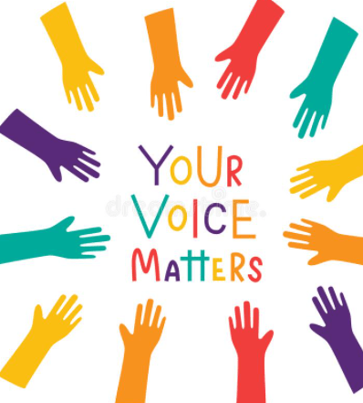

You shared so many rewards which already happen in school, we can’t fit them all in!!
Stickers/Hot Choc/extra play/ray of sunshine/commendations/pride in the book/table points/marbles = movie
Year 1
New rewards suggestions:
Name in a book for those being really kind
A sticker on your home learning
Good for the whole year a treat from the NISA shop
Consequence suggestions:
Playground by yourself

Year 5
Rewards
Laptops
Youtube drawing
Extra play
Board games
Movie/BBC episode
Flower award for showing respect

Consequences
Don’t take part in fun lessons
Letter sent to parents
Go to better choices room, write a letter to parents to say why you are in there.
If you interrupted lessons, apologise to the class

Year 6
Rewards
Fidget Friday
Laptop time
Extra play with a friend
Consequences
No chair when not behaving on it
No play with friends

Next meeting
Wed 25th March
1.10
Pride in the Badge
Ideas to remember Mrs Lattimer
Plant favourite plant
Tree
Bench
Poster
Reading area in woodland

You thought that consequences for KS1 should be different to Ks2, as you thought KS2 should know the rules.
Year 3
Rewards
Playdough box
Box of prizes
Arts and crafts
Sports
Screen time
Consequences
Teachers choose consequence/children choose rewards

Y6 might not want the same rewards as KS1.

Year 4
Rewards
Mini wet play
Lucky dip prizes
Wear own clothes (only if really good)
Consequences
If really bad red card, no warnings
Finish unfinished work at break/lunch/take home

