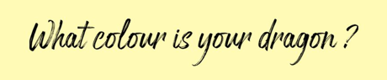

What colour is your dragon is a social and emotional learning framework based on predominantly the science of compassion and mindfulness. It supports emotional regulation via developing a common shared language.

What is a compassionate school?
A compassionate school is one in which the ‘reds’ are allowed to be expressed and not met with punishment. Ok not to be OK.
At the heart of our WCIYD programme is our green dragon, this is a brain state that is achieved when certain chemicals and hormones are flooding through the brain creating this soup of compassion and care. These chemicals and hormones impact on our movement, thinking, relating and speech. When our green is with us, we are calm connected and ready to learn.
When it comes to learning we are interested in the brain state of our blue dragon which is the drive system. This is when we are asked to focus our attention, minimize distractions and stay on task. That’s easy to do if we’ve been nourishing our green dragon, and we are feeling safe and happy and rested. It’s a bit more difficult when we are tired, hungry or angry and full of emotions.
That’s why we need to listen to our red dragon. Red Dragon emerges when things are not as we want them to be. Whether that’s for ourselves as individuals for our families and those that we love and care about. Or for our society or our planet. There is a lot of Red Dragon around at the moment as people are feeling uncertain and scared, a bit worn out and tired.
Listening to the red dragon is a compassionate act, sharing what makes you red in a safe environment, is a way to activate the green dragon, when green dragon is with us, we can do our studies and we can make our mark on the world in our own unique way.
So in the what colour is your dragon training we learn to love and recognise the signatures in the brain and the body of all three dragons , it gives us both permission and language to share our dragons with others, and through this we can create truly compassionate environments where everybody has the opportunity to thrive.

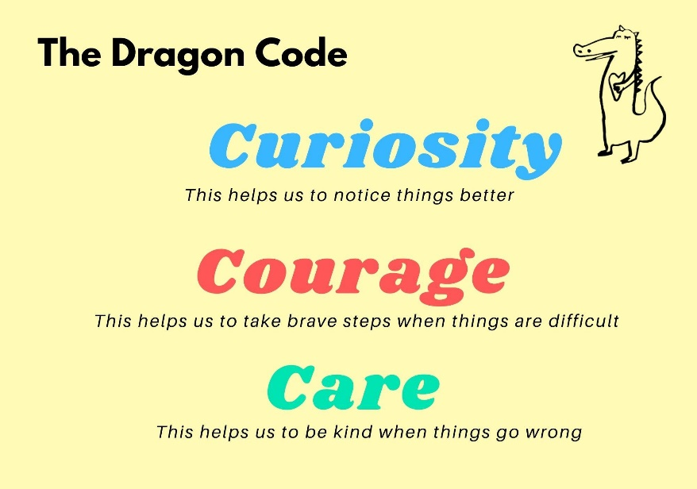
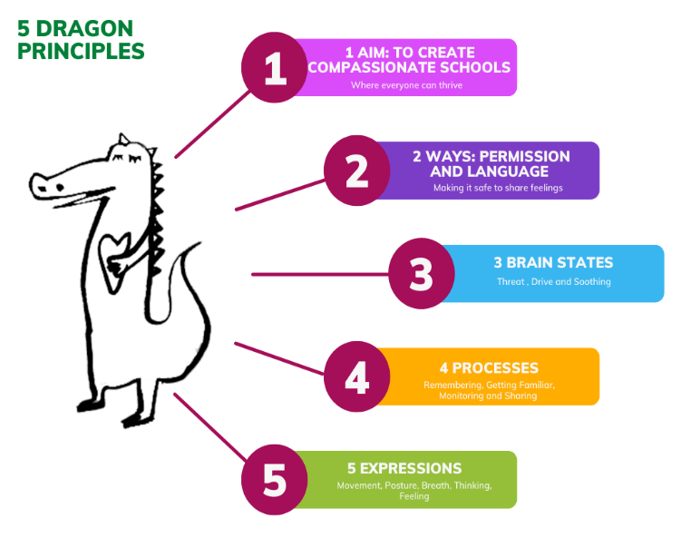

The 3 brain states/dragons
Based on Paul Gilbert’s evolutionary model of human motivational systems.
THREAT – Mindset focused on seeking protection from danger (RED DRAGON)
DRIVE – Mindset attuned towards wanting / seeking / aspiring / accomplishing (BLUE DRAGON)
SOOTHE – Mindset attuned to giving or receiving care / affecting / nurturance (GREEN DRAGON)
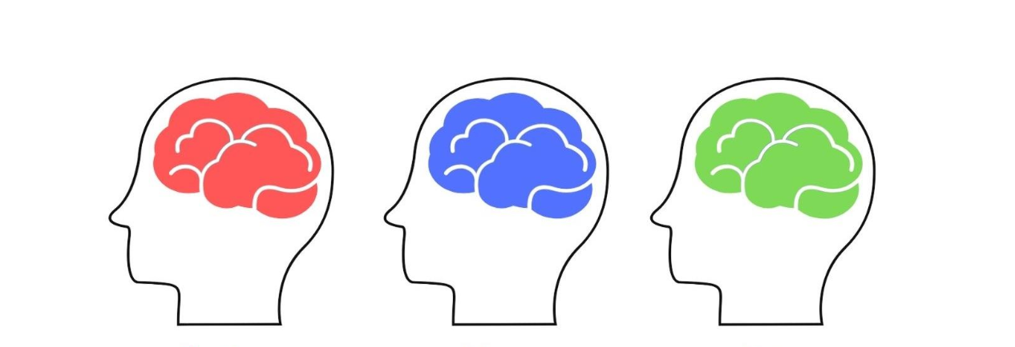

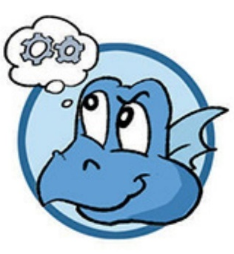
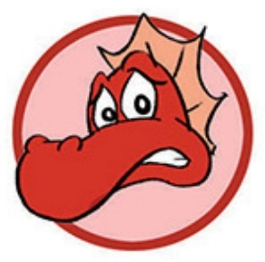
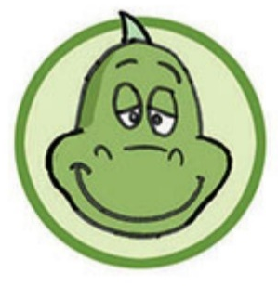

_______________________________________________________________________________
PAUSE!
CAMERA OUT CAMERA IN


